Exercise

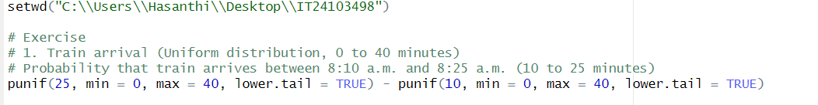01.



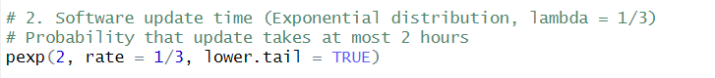02.

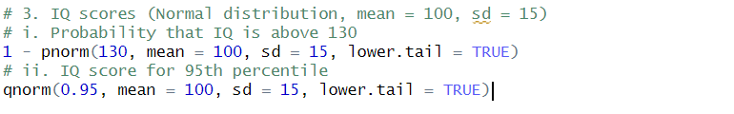03.

